Retrieving and Parsing Data from RESTful APIs
Lab Execution and GitHub Publishing — Step-by-Step Guide

Part 1: Running the Lab
Walk through each step in order, running the corresponding script and capturing or confirming the listed result. Run everything from the project root folder.

Step 01 — Create the Project Folder
Create a dedicated folder for this lab. This keeps scripts, screenshots, and docs organized.
mkdir PowerShell-RESTful-APIs
cd PowerShell-RESTful-APIs
mkdir scripts, screenshots, docs
Open the folder in File Explorer or VS Code (code .) and confirm you see scripts, screenshots, and docs subfolders.

Step 02 — Make a Basic API Request
Create scripts\Task1-API-Request.ps1. Use Invoke-RestMethod to call a public REST endpoint and display the response in the console.
$response = Invoke-RestMethod -Uri 'https://jsonplaceholder.typicode.com/posts'
$response
Expected: a table of posts is returned, with columns userId, id, title, and body.
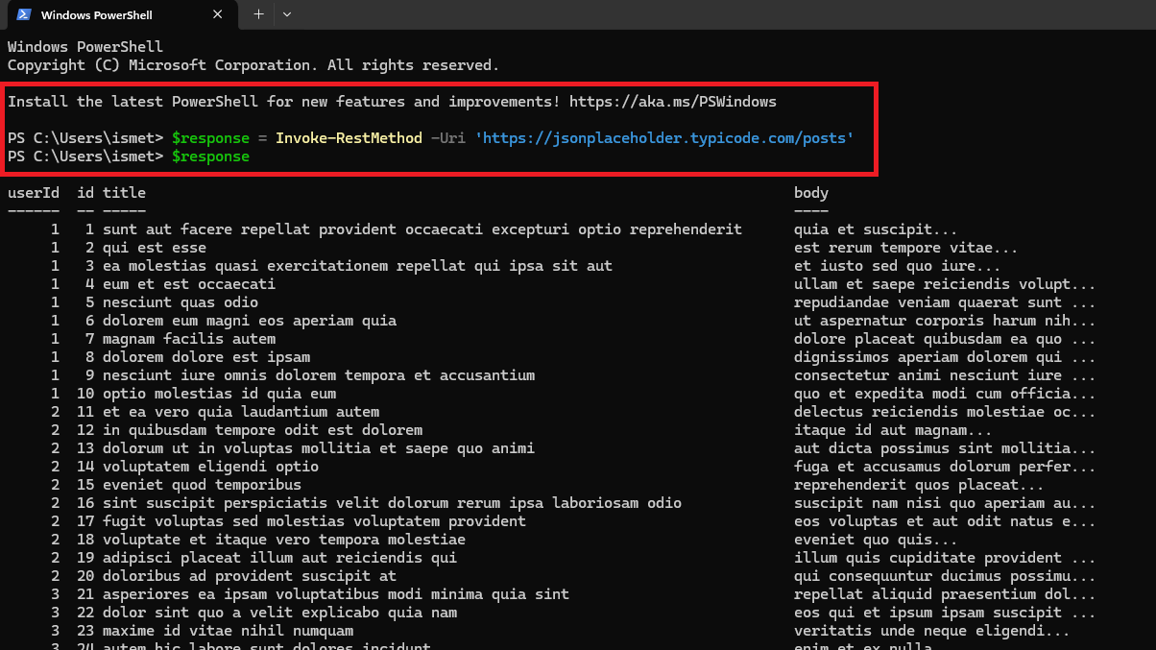
Task 1 — basic Invoke-RestMethod call returning post data from jsonplaceholder.typicode.com.

Step 03 — Parse JSON and Extract Specific Fields
Create scripts\Task2-Parse-JSON.ps1. Define a sample employeeList JSON string, convert it with ConvertFrom-Json, and loop through it to display each employee's first and last name.
$jsonData = '{
"employeeList": [
{ "id": 101, "firstName": "John", "lastName": "Bason", "department": "HR" },
{ "id": 102, "firstName": "Mr. PBC", "lastName": "MXZ", "department": "IT" },
{ "id": 103, "firstName": "Mr. ABC", "lastName": "XYZ", "department": "Admin" }
]
}'
$parsed = $jsonData | ConvertFrom-Json
foreach ($emp in $parsed.employeeList) {
Write-Host "Employee Name: $($emp.firstName) $($emp.lastName)"
}
Expected console output: Employee Name: John Bason Employee Name: Mr. PBC MXZ Employee Name: Mr. ABC XYZ
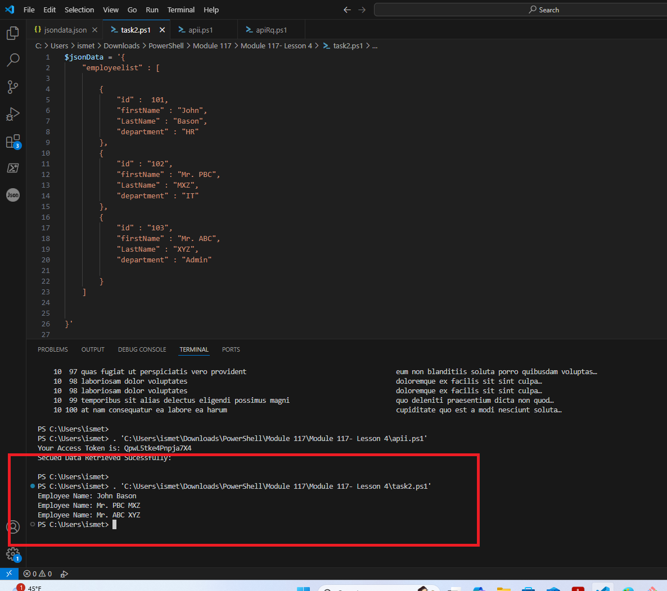
Task 2 — task2.ps1 parsing the employeeList JSON and printing each employee's full name.

Step 04 — Authenticate and Call a Secured Endpoint
Create scripts\Task3-Authorization.ps1. Log in to get an access token, then attach it as a Bearer token in the Authorization header for a follow-up request.
$body = @{
"email" = "eve.holt@reqres.in"
"password" = "cityslicka"
}
$jsonBody = $body | ConvertTo-Json
$response = Invoke-RestMethod -Uri 'https://reqres.in/api/login' -Method Post -Body $jsonBody -ContentType 'application/json'
$accessToken = $response.token
Write-Host "Your Access Token is: $accessToken"
$headers = @{ 'Authorization' = "Bearer $accessToken" }
$response = Invoke-RestMethod -Uri 'https://jsonplaceholder.typicode.com/posts' -Headers $headers
if ($response) {
Write-Host "Secured Data Retrieved Successfully:"
} else {
Write-Host "No Data Received"
}
Expected console output: Your Access Token is: QpwL5tke4Pnpja7X4 Secured Data Retrieved Successfully:
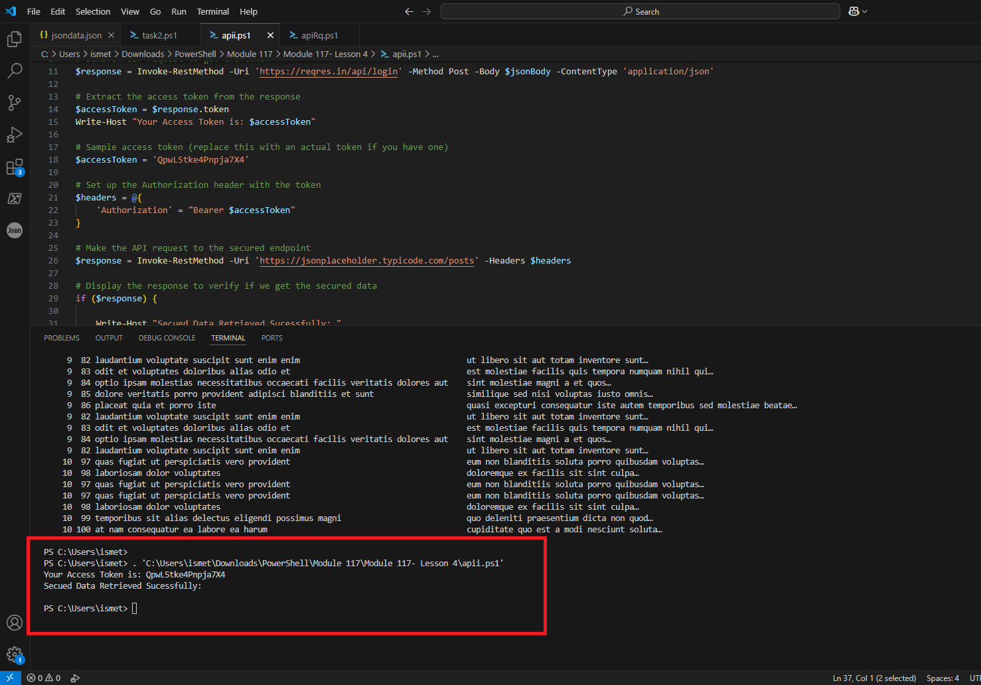
Task 3/4 — apii.ps1 logging in, retrieving the access token, and successfully calling the secured endpoint with the Authorization header.

Step 05 — Confirm Authorization Handling Works End-to-End
Re-run Task3-Authorization.ps1 from a clean terminal to confirm the token retrieval and secured call both succeed reliably, not just on the first run.
Expected: the same two confirmation lines appear again — Your Access Token is: ... and Secured Data Retrieved Successfully:

Step 06 — Verify Final Files
Open File Explorer at the project root and confirm scripts/ has Task1-API-Request.ps1, Task2-Parse-JSON.ps1, and Task3-Authorization.ps1, and screenshots/ has all your captures.

